

*Wedding Invitation*

You are Invited to our Wedding Ceremony, Please describe the event briefly here

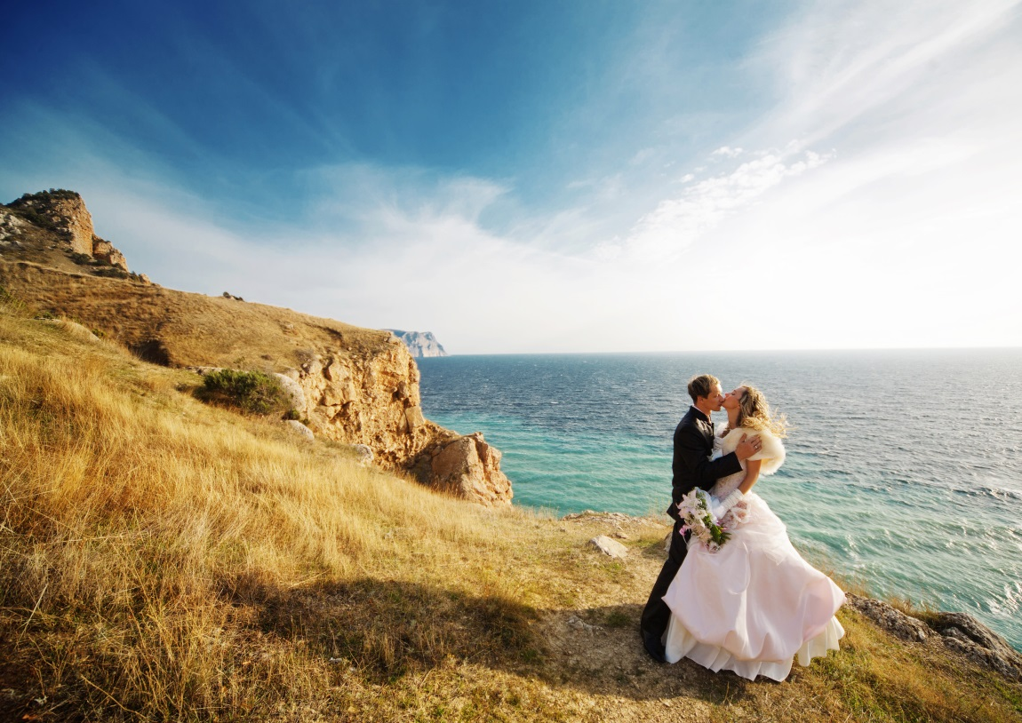

**YOUNG WON**

*and*

**SA RANG**

March 17, 2017 Sunday at 3pm

ARTS INCUBATOR EVENT LOFT

115W 18th Street Kansas City, Missouri